A000-ME-Anatolia-Köşk Höyük-Mother goddess figurine-Terra Cotta, 5500-5000 BCE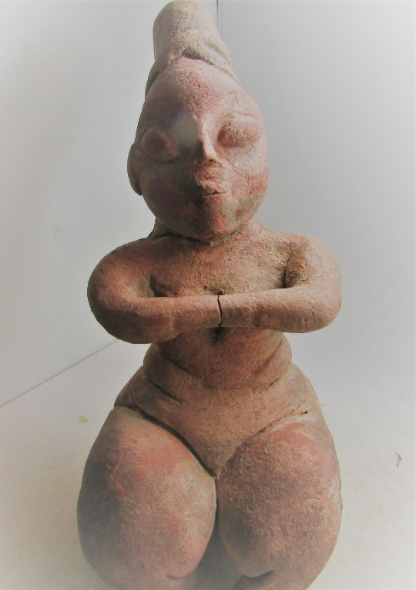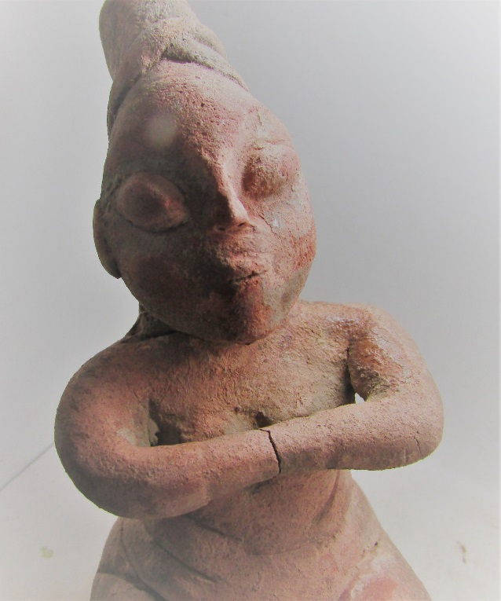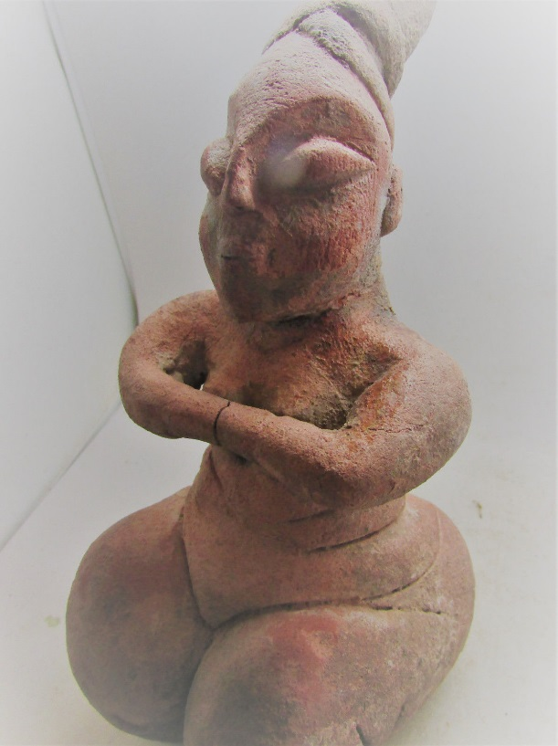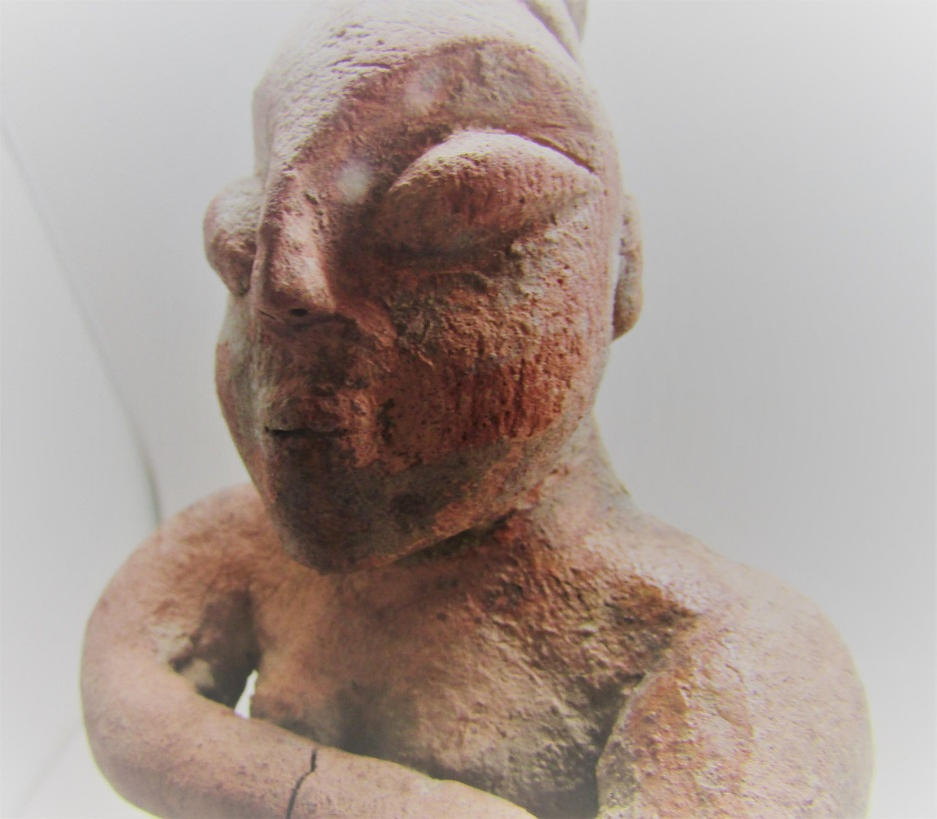  
  
**Case no.: 1**

**Accession Number:**

**Formal Label:** ME-Anatolia-Köşk Höyük-Mother goddess figurine-Terra Cotta, 5500-5000 BCE

**Display Description:**

This rare female figurine deity of the Köşk Höyük culture, is situated on the rocky plateau on the edge of the Bor Plain. It evolved some 90 miles north of Çatalhöyük in the same time horizon and exemplifies the development of a discrete yet regionally integrated early Neolithic set of attributes for this city complex. The mother goddess figurines; bulls' heads and polychrome ceramics at the site of Kösk Höyük have many similarities with the sites of Çatalhöyük, Can Hasan and Hacilar.

This Mother goddess figurine is seated with arms joined at her front, a gestural posture related to her hearing the entreaties of her acolytes. Speculatively the joining of her hands suggests that she is wearing some sort of hand muff that conceals her lower arms and fingers. Moreover, the placement of the hands over her beasts suggests that the importance of her power lies less in her fertility than in her powers of mind.

She is wearing a tall cylindrical headdress, tilted backwards that is her badge of office. The supple structure of this headdress suggests that it is made of wool, it is covering a high-styled hairdo that requires a hairdresser and that the economic culture of Köşk Höyük was wool-production. Köşk Höyük was on a easterly series of trade routes that had been engaged in down-the-line trade with other cities in the area such as Çatalhöyük West (Biehl *et al.* 2012: 53-64) in a variety of materials including obsidian, which was probably used in making backed obsidian blades to harvest wheat which was grown in the area as one of the first Emmer Wheat sources. The production of wheat was probably the produce that was engaged in down-the-line trade and exchange with Mersin Yumuktepe (Garstang 1953; Caneva and Sevin 2004; Caneva and Koroglu 2010) and Mesopotamian cities such as El ‘Ubaid on the Euphrates River that was responsible for the dissemination of this cultigen down the Euphrates River sites all the way to Sumer.

The eyes of this figurine are distinctively almond-shaped, like those of Minoans and Egyptians and while there Is no evidence that this area participated in contact with these civilizations the function of the almond or front-facing eye was to signal the perspicacity if not meditative capacity to see into the worlds beyond, perhaps with the assistance of hallucinogens or other stimulatory agents. In any case the eyes of these figurines suggests kind of omniscience and hence the ability to offer advice and council to those who would offer entreaties or meditate on her attributes, such as in a fire kasina meditative practice. The posturing of this figurine is also essential as a model for the establishment of the meditative endeavor at Köşk Höyük. Her legs are tucked under her body in a ritualistic pose.

The steatopygia and thickness of her legs suggests that this culture is confident in its production of high caloric intake from its produce and its sedentary Neolithic life-style. In this sense this figurine emulates those figurines from Çatalhöyük and other Neolithic sites on the Konya Plain.

**LC Classification: GN776.32**

**Date or Time Horizon:** 5500 BCE

**Geographical Area:** Konya Plain, Turkey

**Map:**

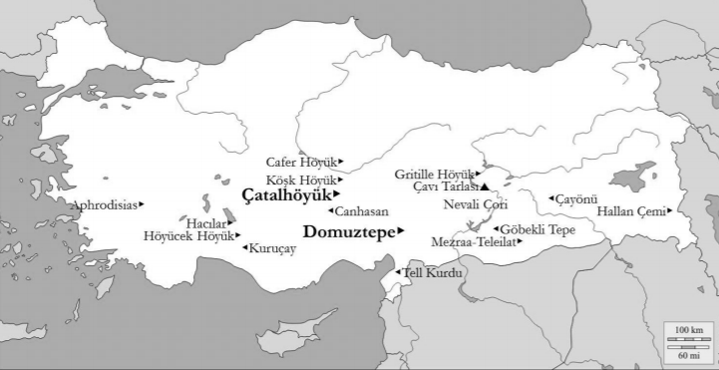

**After** Belcher, E and K. Croucher. (2016)

**GPS coordinates:**

**Cultural Affiliation:** Konya Plain Neolithic

**Medium:** terracotta

**Dimensions:**

**Weight:**

**Condition: original**

**Provenance:** Konya, Turkey

**Discussion:**

Excavations at the Köşk Höyük on the rocky slope to the east of the Roman pool in the town of Niğde in the Bahçeli province have shown that its main strata date to the Late Neolithic to the Early Chacolithic Periods (Silistreli 1984, 2007:223-235; 2002:55-69). To the east are several cities that were connected with these meandering overland routes Anatolia offered these Neolith sites a flourishing landscape rich in materials like obsidian, salt, clay, minerals including copper. The recent C-14 dates for many of the sites to the east of Köşk Höyük (Tepecik Çiftlik, Gelveri-Yuksekkilise, Güzelyurt-Arsaray and Guvercinkayasi) provides a glimpse of a holistic cultural phenomenon of successful expendable production of trade goods that also facilitated exchange of ideas and their incorporation into cultural endeavors such as religiosity, architecture, city planning and care for the dead.

Recent excavations shows that the oldest agriculture and stockbreeding community of the Bor plain is located in this area. The first four layers of Köşk Höyük settlement are Late Neolithic and the Late Chalcolithic Age. In the Neolithic period, there is an architecture consisting of small rooms with multi-rooms that can be expanded according to the need. In the Chalcolithic period, two to four room houses were organized into blocks that line irregular streets that separate block from each other demonstrating nascent city-wide planning and the evolution of hierarchical control and city management (Öztan 2007, 2002).

|  |  |
| --- | --- |
| Period Approx. | Date (BCE cal) |
| Early Aceramic Neolithic Key sites with figurines: Göbekli Tepe (early), Hallan Çemi, | ~10000–8550 BCE cal (10th–9th millennia) |
| Late Aceramic Neolithic or PrePotteryNeolithicB Key sites with figurines: Çatalhöyük, Çayönü, Göbekli Tepe, Cafer Höyük, Hacılar, Gritille Höyük, Mezraa-Teleilat, Nevali Çori | 8550–6750 BCE cal (9th–8th millennia) |
| Ceramic Neolithic Key sites with figurines: Hacılar IX–VI, Höyücek Höyük, Kuruçay Höyük, Mezraa-Teleilat | 6750–6000/5900 BCE cal (8th–7th millennia) |
| Halaf or **Early–Middle Chalcolithic Key sites with figurines:** Aphrodisias (Pekmez), **Çatalhöyük West,** Çavı Tarlası, Canhasan I, Domuztepe, Hacılar (VII–I), **Köşk Höyük**, Tell Kurdu | 6000/5900–5200/5000 BCE cal (6th millennium) |

Chronology and periods of main sites with published figurine data. After Belcher, E and K. Croucher. (2016)

The burial of the deceased in the floor of the dwellings continued with most adults and some children having the cranium separated from the body with the facial features stained with the paint is to suggest their continuing vitality. This feature of treating the crania of the dead is also observed in Palestine, Israel, Jordan and Southern Syria between 10-8 ky BCE, which may have been the source of the practice.

**References:**

Anon. 2012. The Chalcolithic Period in Central Anatolia: the Arksaray-Niğde Region. Origini - XXXIV:

Belcher, E and K. Croucher. (2016) Exchanges of Identity in Prehistoric Anatolian Figurines. In, R. A. Stucky, O. Kaelin & H. P. Mathys (Eds.) Proceedings of the 9th International Congress on the Archaeology of the Ancient Near East (9th ICAANE). Wiesbaden: Harrassowitz Verlag, Vol. I, pp. 43-56.Preistoria e protostoria delle civiltà antiche.

Garstang, J., 1953. *Prehistoric Mersin: Yümük Tepe in Southern Turkey*. Clarendon Press.Caneva and Sevin 2004;

Caneva, I. and G. Koroglu. 2010. Yumuktepe Doktuzbin Yillik Yoculuk, Ege Yayin;ari. Istanbul.

Mellart, J., 1967. Çatal Hüyük. *A Neolithic Town In Anatolia, London*.   
Öztan, A. 2002, **Köşk Höyük Anadolu Arkeolojisini Yeni Katkilar. Tüba/AR 5:55-69.**

Öztan, A.

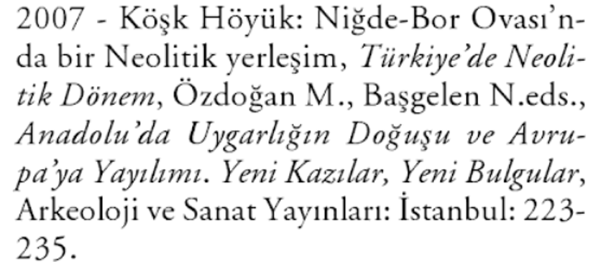

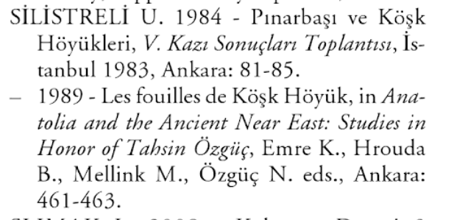

Yakar, J., 1991. *Prehistoric Anatolia: the neolithic transformation and the early chalcolithic period* (No. 1). Institute of Archaeology.

**Appendix**

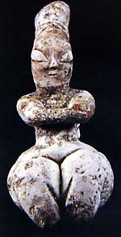   
  
Koskhoyuk   
Late Neolithic, second half of 6th mill. B. C.   
Baked clay   
Nigde Museum.